# Overview

This document contains the necessary information to build the Adaptive Utensils, a set of adjustable and interchangeable 3D printed adaptive utensil handles.

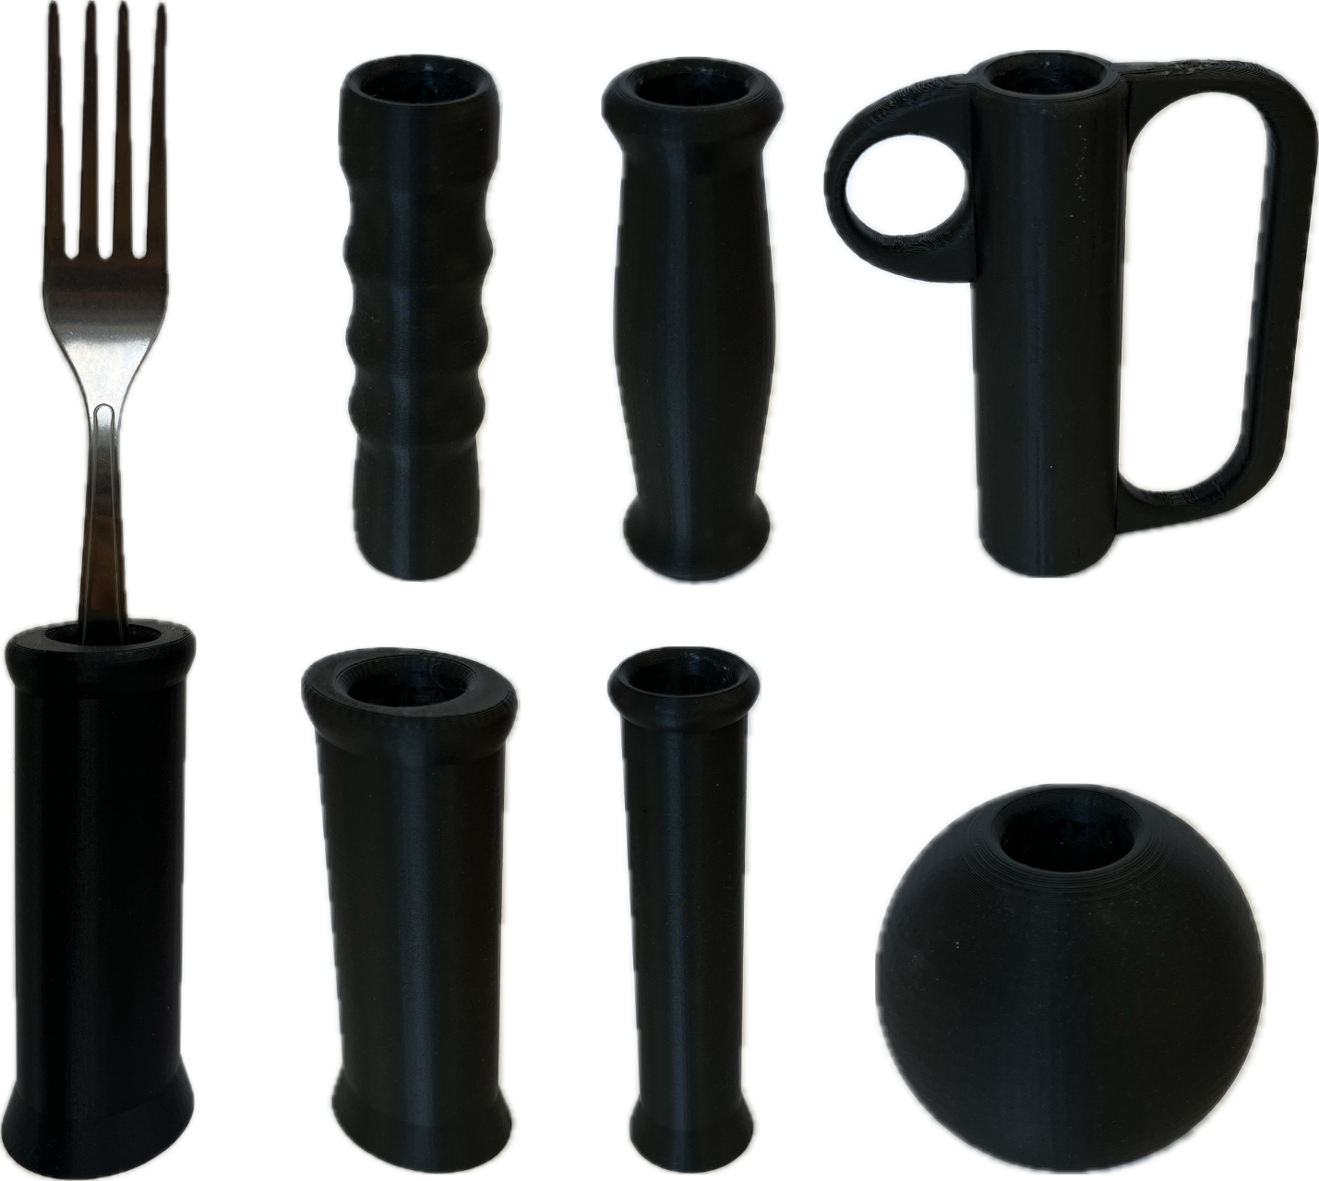

Contents

Overview 1

Maker Checklist 3

Maker To Do List 3

Items to Give to User 3

Tool List 4

Tools / Equipment 4

Supplies 4

Personal Protective Equipment (PPE) 4

Customization Guide 5

3D Printing Guide 5

3D Printing Summary 5

3D Printing Settings 5

Post-Processing 6

Examples of Quality Prints 7

Maker Component List 9

Assembly Guide 11

Part A: 3D Printed Adaptive Utensils 12

Part A: Required Components 12

Part A: Required Tools and Supplies 13

Part A: Required Personal Protective Equipment (PPE) 13

Part A: 3D Printed Adaptive Utensils Assembly Steps 13

Testing 15

Troubleshooting 15

# Maker Checklist

This list provides an overview of the steps required to build and deliver the 3D Printed Adaptive Utensils.

## Maker To Do List

* Read through the Maker Guide to become familiar with required components, tools, supplies, safety gear, and overall assembly steps.
* Talk to the User about customization options
  + Handle type, size, and quantity (Ellipse, Finger Grip, Finger Support-Large/Small, Rounded Grip, Sphere-Large/Small, Straight-Large/Small)
  + Number and types of core assemblies (Spoon or Fork Core)
  + Print color
  + How they would like to receive the “User Guide” (PDF or physical copy)
* Order hardware components
* Gather tools, supplies, and safety equipment.
* Assemble the device
* Test the 3D Printed Adaptive Utensils
* Print “User Guide” (if the User would like a physical copy)

## Items to Give to User

* The desired handle types in the correct size and quantity (Ellipse, Finger Grip, Finger Support-Large/Small, Rounded Grip, Sphere-Large/Small, Straight-Large/Small)
* Spoon and fork core assemblies (each assembly consists of 1 core and 1 shell part)
* IKEA IDENTITET large spoon and fork utensils
* Note: All cores and handles should be tested for assembly and adjustability before giving to user, however they may be disassembled for easier transportation
* “User Guide”

# Tool List

## Tools / Equipment

|  |  |  |  |
| --- | --- | --- | --- |
| Tool ID | Description | Required / Recommended | Notes |
| T01 | 3D printer | Required | To manufacture the 3D Printed Adaptive Utensils |
| T02 | Putty knife or similar scraper | Recommended | To remove small or thin parts from the build plate |
| T03 | Flush cutters or pliers | Recommended | To remove support |

## Supplies

|  |  |  |  |  |
| --- | --- | --- | --- | --- |
| Supplies ID | Description | Quantity | | Notes |
| S01 | PLA Filament | 326.53g | For 3D printing the handles | |
| S02 | PETg Filament | 25.21g | For 3D printing the spoon/fork cores and the core shells | |

## Personal Protective Equipment (PPE)

|  |  |  |
| --- | --- | --- |
| PPE ID | Description | Notes |
| P01 | Safety Glasses | To protect eyes against occasional flying filament when removing supports |

# Customization Guide

There are separate STL files for different size options of certain handle types. The handles and cores may be printed in the user’s desired color.

# 3D Printing Guide

The device was originally printed on a BambuLab X1-Carbon using Bambu Studio.

Used default settings with 0.2mm layer height and a 0.4mm nozzle for both PLA and PETG filament on a textured PEI build plate. Enabled tree supports for relevant files.

## 3D Printing Summary

To print a full set of handles and cores (one copy of each handle file, both types of cores, and two shells)

|  |  |
| --- | --- |
| **Metrics** | **Single Unit** |
| Total Print Time (hour min) | 17h29 |
| Total Number of Components | 13 |
| Typical Total Mass (g) | 351.74g |
| Typical Number of Print Setups | 5 |

## 3D Printing Settings

Note that the 3D printing material should be assumed to be PLA unless otherwise noted in the table below.

|  |  |  |  |  |  |  |  |
| --- | --- | --- | --- | --- | --- | --- | --- |
| **Print File Name** | **Qty** | **Total Print Time (hr:min)** | **Mass (g)** | **Infill (%)** | **Support(Y/N)** | **Layer Height/ Nozzle Diameter(mm)** | **Notes** |
| Adaptive_Utensils_IKEA_Core-Fork | 1 | 1:10 | 9.06 | 15 | Y | 0.2mm Layer Height, 0.4mm Nozzle Diameter | PETg |
| Adaptive_Utensils_IKEA_Core-Spoon | 1 | 1:10 | 8.99 | 15 | Y | 0.2mm Layer Height, 0.4mm Nozzle Diameter | PETg |
| Adaptive_Utensils_IKEA_Shell | 2 | 0:52 | 7.16 | 15 | N | 0.2mm Layer Height, 0.4mm Nozzle Diameter | PLA |
| Adaptive_Utensils_IKEA_Ellipse | 1 | 1:32 | 32.78 | 15 | N | 0.2mm Layer Height, 0.4mm Nozzle Diameter | PLA |
| Adaptive_Utensils_IKEA_FingerGrip | 1 | 1:34 | 25.65 | 15 | N | 0.2mm Layer Height, 0.4mm Nozzle Diameter | PLA |
| Adaptive_Utensils_IKEA_FingerSupport-Large | 1 | 2:01 | 50.84 | 15 | Y | 0.2mm Layer Height, 0.4mm Nozzle Diameter | PLA |
| Adaptive_Utensils_IKEA_FingerSupport-Small | 1 | 2:00 | 50.19 | 15 | Y | 0.2mm Layer Height, 0.4mm Nozzle Diameter | PLA |
| Adaptive_Utensils_IKEA_RoundedGrip | 1 | 1:36 | 30.29 | 15 | N | 0.2mm Layer Height, 0.4mm Nozzle Diameter | PLA |
| Adaptive_Utensils_IKEA_Sphere-Large | 1 | 1:19 | 45.38 | 15 | N | 0.2mm Layer Height, 0.4mm Nozzle Diameter | PLA |
| Adaptive_Utensils_IKEA_Sphere-Small | 1 | 0:42 | 20.85 | 15 | N | 0.2mm Layer Height, 0.4mm Nozzle Diameter | PLA |
| Adaptive_Utensils_IKEA_Straight-Large | 1 | 1:51 | 48.98 | 15 | N | 0.2mm Layer Height, 0.4mm Nozzle Diameter | PLA |
| Adaptive_Utensils_IKEA_Straight-Small | 1 | 1:42 | 25.15 | 15 | N | 0.2mm Layer Height, 0.4mm Nozzle Diameter | PLA |

## Post-Processing

Use flush cutters (T02) to remove tree supports from the spoon and fork cores as well as the small and large finger support handles. Inspect the 3D printed parts for any printing defects, sharp edges, or burrs. Sharp edges and burrs can be removed with sanding or deburring tools.

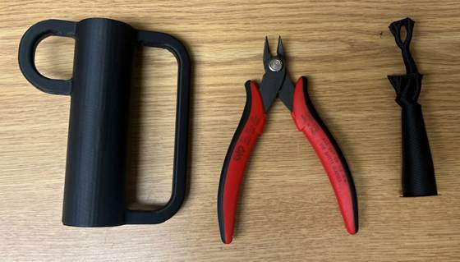

## Examples of Quality Prints

Compare your 3D prints to the images here. If there are significant differences, you may need to reprint the part.

|  |  |  |
| --- | --- | --- |
| Adaptive Utensil Handles | | |
| Adaptive_Utensils_IKEA_Core-Fork | Adaptive_Utensils_IKEA_Core-Spoon | Adaptive_Utensils_IKEA_Shell |
|  |  |  |
| Adaptive_Utensils_IKEA_Ellipse | Adaptive_Utensils_IKEA_FingerGrip | Adaptive_Utensils_IKEA_FingerSupport-Large |
|  |  |  |

|  |  |  |
| --- | --- | --- |
| Adaptive Utensil Handles |  |  |
| Adaptive_Utensils_IKEA_FingerSupport-Small | Adaptive_Utensils_IKEA_RoundedGrip | Adaptive_Utensils_IKEA_Sphere-Large |
|  |  |  |
| Adaptive_Utensils_IKEA_Sphere-Small | Adaptive_Utensils_IKEA_Straight-Large | Adaptive_Utensils_IKEA_Straight-Small |
|  |  |  |

# Maker Component List

|  |  |  |  |  |  |  |  |  |  |  |  |  |  |  |
| --- | --- | --- | --- | --- | --- | --- | --- | --- | --- | --- | --- | --- | --- | --- |
| Adaptive Utensil Handles | | | | | | | | | | | | | | |
| A01 | Fork Core | | | QTY: 1 | A02 | Spoon Core | | | QTY: 1 | A03 | Shell | | | QTY: 2 |
|  | | | | |  | | | | |  | | | | |
| A04 | Ellipse | | | QTY: 1 | A05 | Finger Grip | | | QTY: 1 | A06 | Finger Support-Large | | | QTY: 1 |
|  | | | | |  | | | | |  | | | | |
| A07 | Finger Support-Small | | | QTY: 1 | A08 | Rounded Grip | | | QTY: 1 | A09 | Sphere-Large | | | QTY: 1 |
|  | | | | |  | | | | |  | | | | |
| A10 | Sphere-Small | | | QTY: 1 | A11 | Straight-Large | | | QTY: 1 | A12 | Straight-Small | | | QTY: 1 |
|  | | | | |  | | | | |  | | | | |
| A13 | | **IKEA IDENTITET FORK** | QTY: 1 | | A14 | | **IKEA IDENTITET SPOON** | QTY: 1 | |  | |  |  | |
| IDENTITET 16-piece cutlery set, stainless steel | | | | | IDENTITET 16-piece cutlery set, stainless steel | | | | |  | | | | |

# Assembly Guide

|  |  |
| --- | --- |
| Assembly Section | |
| 3D Printed Adaptive Utensil Assembly |  |

## Part A: 3D Printed Adaptive Utensils

### Part A: Required Components

|  |  |  |  |  |  |  |  |  |
| --- | --- | --- | --- | --- | --- | --- | --- | --- |
| 3D Printed Adaptive Utensils | | | | | | | | |
| A01 | Fork Core | QTY: 1 | A02 | Spoon Core | QTY: 1 | A03 | Shell | QTY: 2 |
|  | | |  | | |  | | |
| A01 | Ellipse | QTY: 1 | A02 | Finger Grip | QTY: 1 | A03 | Finger Support-Large | QTY: 1 |
|  | | |  | | |  | | |
| A01 | Finger Support-Small | QTY: 1 | A02 | Rounded Grip | QTY: 1 | A03 | Sphere-Large | QTY: 1 |
|  | | |  | | |  | | |
| A01 | Sphere-Small | QTY: 1 | A02 | Straight-Large | QTY: 1 | A03 | Straight-Small | QTY: 1 |
|  | | |  | | |  | | |

### 

### Part A: Required Tools and Supplies

* 3D Printer (T01)
* Scraper Tool (T02)
* Flush Cutters (T03)
* PLA Filament (S01)
* PETg Filament (S02)

### Part A: Required Personal Protective Equipment (PPE)

* Safety Glasses (P01)

### Part A: 3D Printed Adaptive Utensils Assembly Steps

#### Step A-01: Utensil Alignment

Press the utensil base into the profile cutout of the corresponding core.

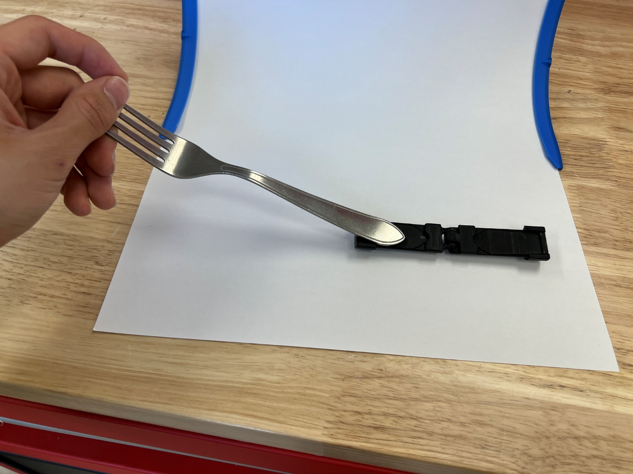

#### Step A-02: Utensil Fit

Close the core halves around the utensil base.

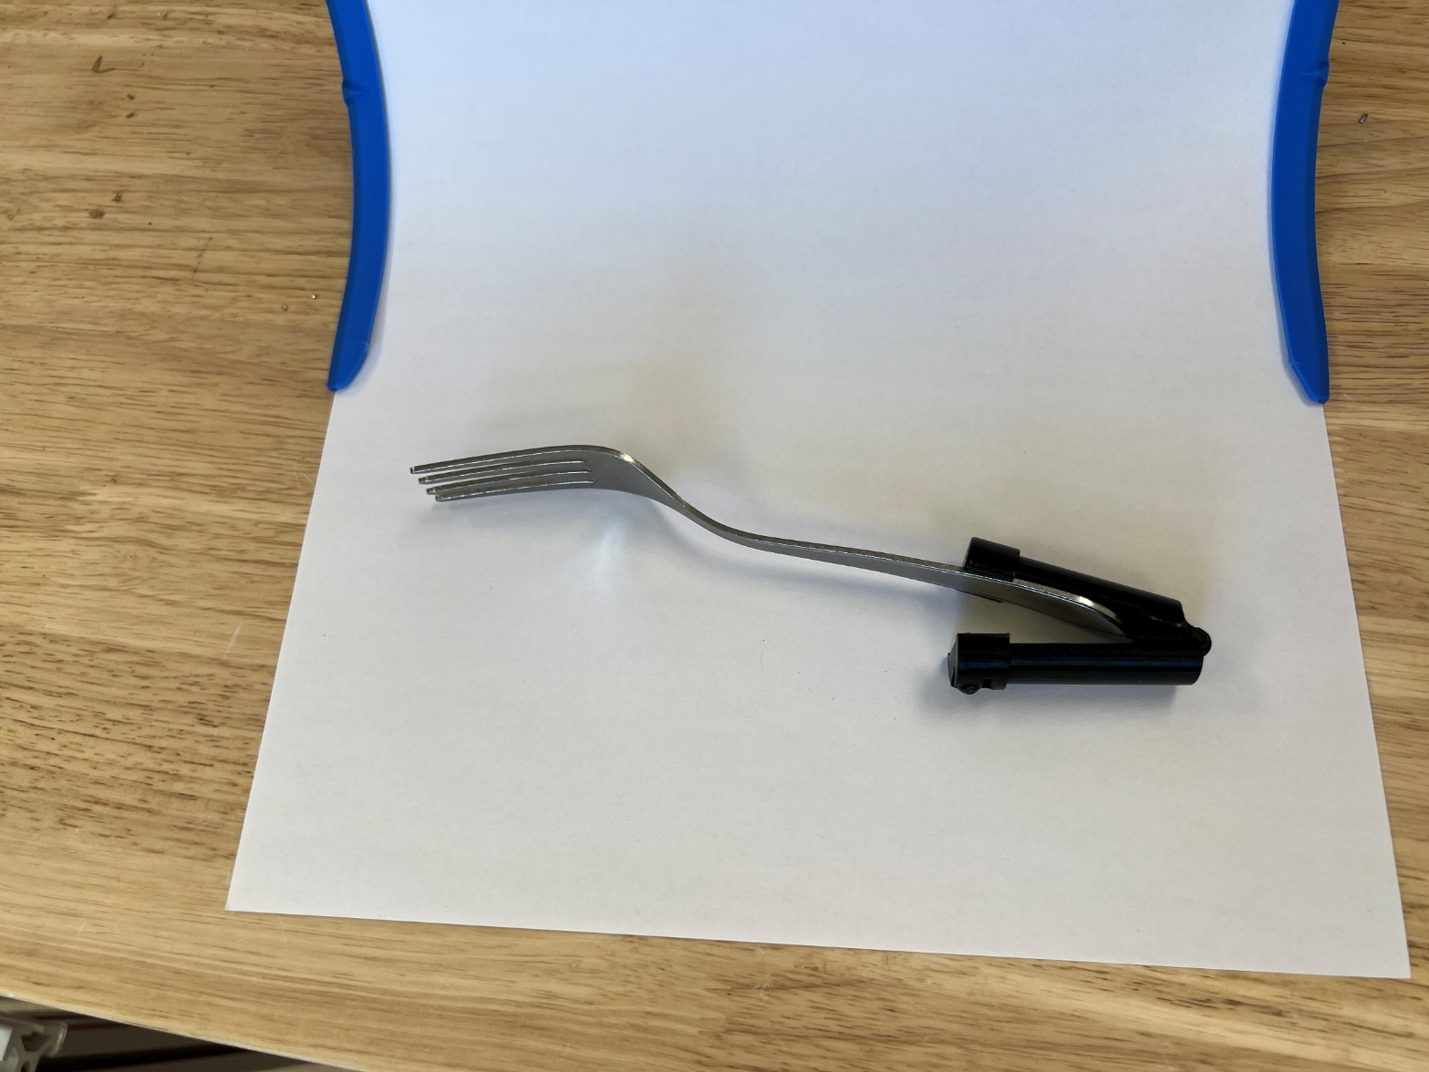

#### Step A-03: Core Assembly

Slide the shell around the core to lock it closed.

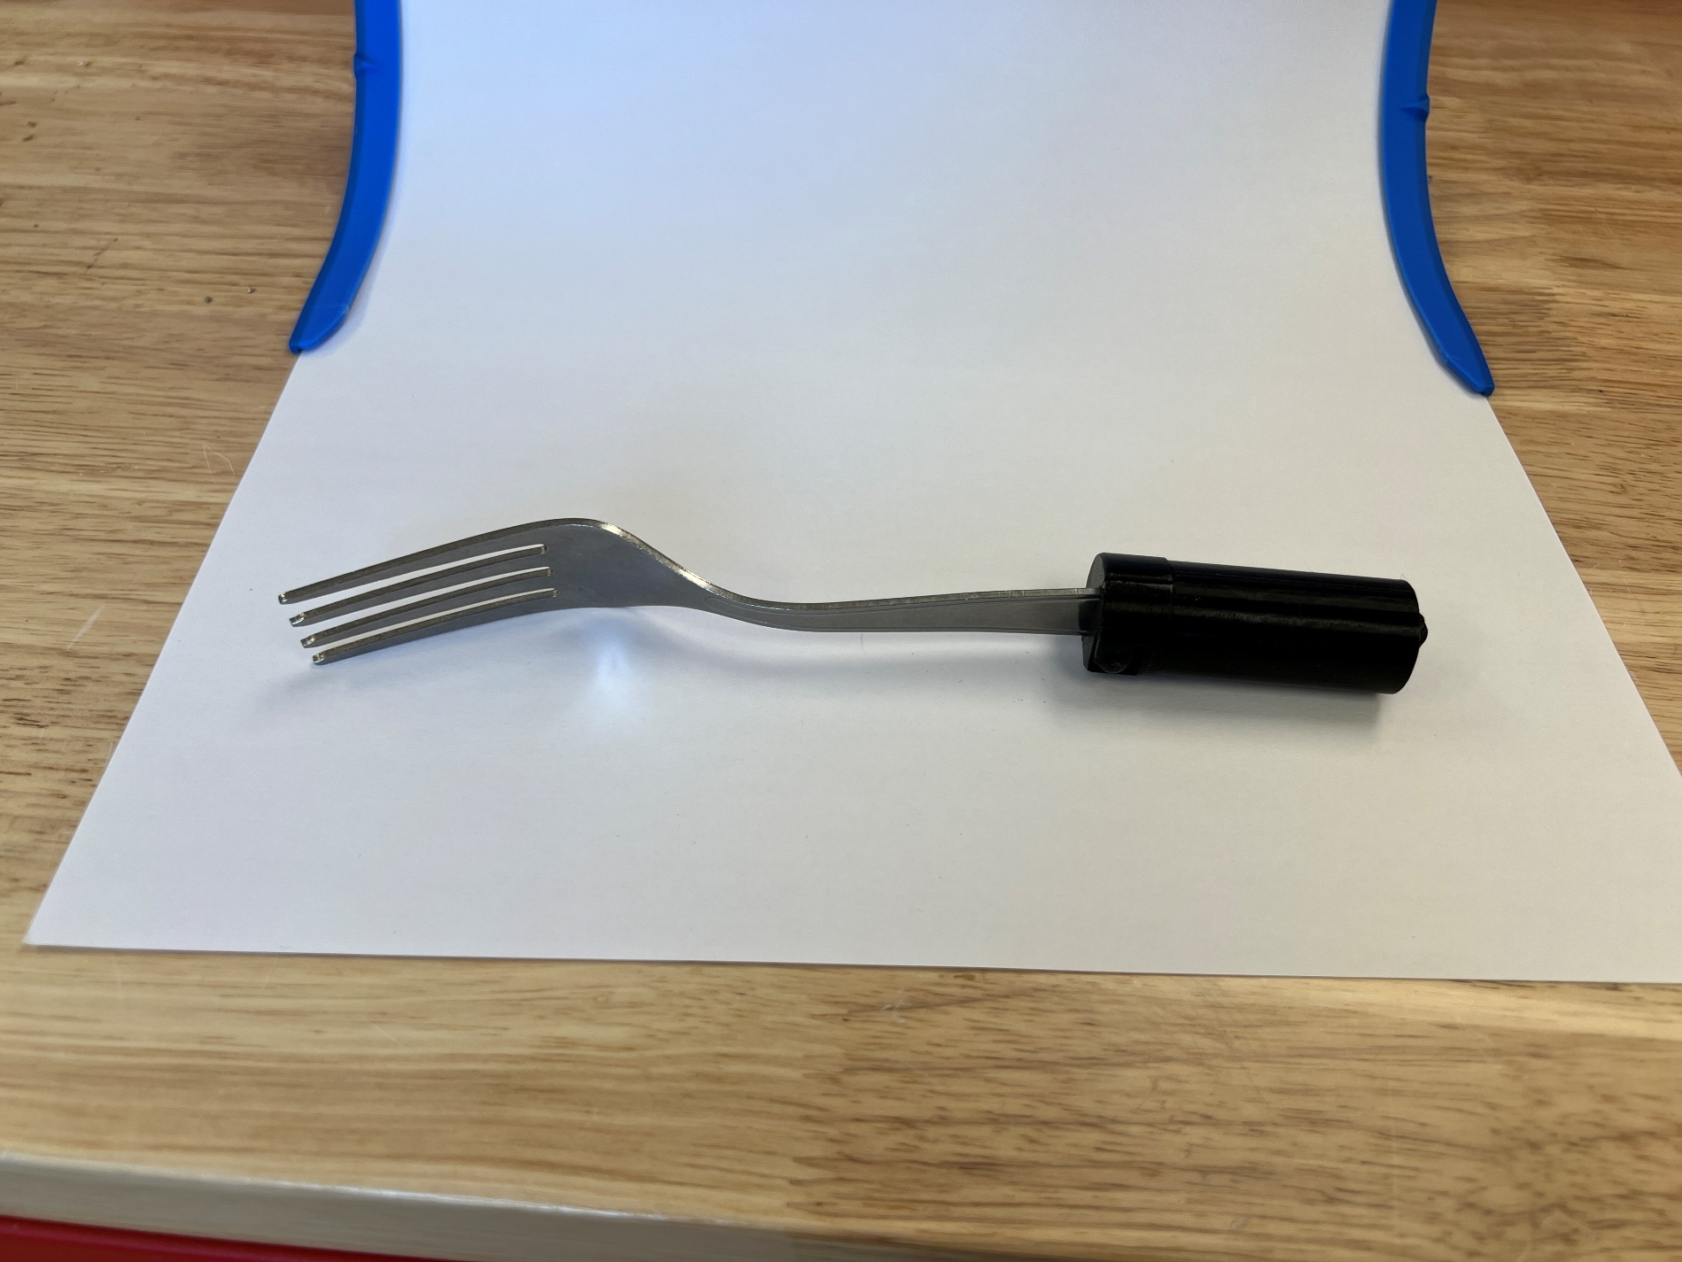

#### Step A-04: Handle Fit

Insert the core assembly into the 3D printed handle. Push and twist the utensil until the ball sockets press into the hemisphere cutouts inside the handle.

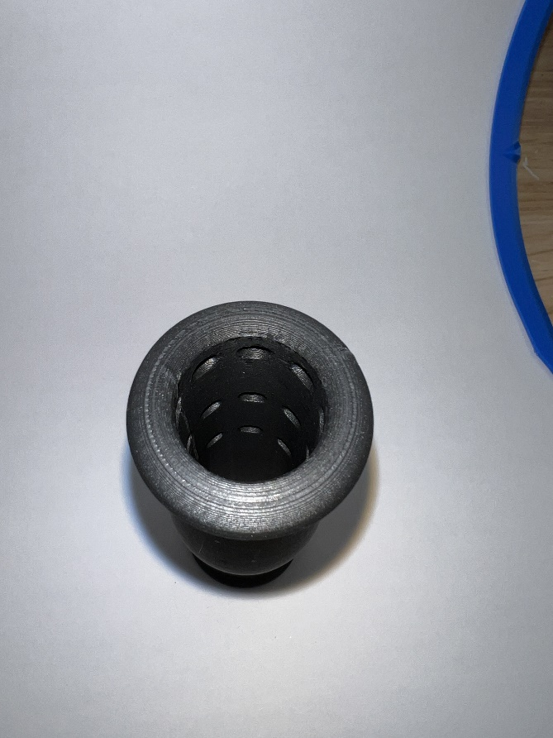

#### Step A-05: Adjustment

There are 3 levels of depth adjustment in increments of 20 mm and 8 levels of rotation adjustment in increments of 45° turns. To change depth and rotation, push, pull, and twist to lock the utensil in the desired position.

#### Assembly Complete

# Testing

Bend the cores open and closed for at least 3 cycles to break in/loosen the print-in-place hinges.

Once the core assembly is put together, test all depth and rotation configurations in each handle.

# Troubleshooting

If the core assembly does not lock inside the handle and slides during regular usage, that means the ball sockets did not properly align with the hemisphere cutouts. Continue to push, pull, and twist the core to find a locking position for the utensil. It may be easier to remove the core assembly, align the ball sockets, then insert the core straight into the handle.

The core assembly may become stuck inside a handle. First, try to pull out the core while rotating it with the utensil. If the core remains stuck, try pressing a thin and long object through the bottom hole of the handle to push it out.

When removing the core assembly, the shell may be left behind inside the handle. To remove the shell from the handle, use a finger or other thin and long object (like a pen) to dislodge it.